**Food Delivery aap**

**Idea Name:- DELICIOUS FOOD**

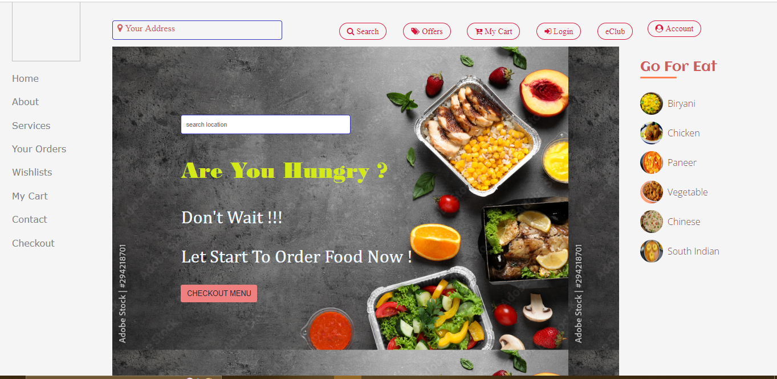

**Description :-** Order food & beverages online from restaurants near & around you. We deliver food from your neighborhood local joints, your favorite cafes, luxurious & elite restaurants in your area. Exciting bit? We place no minimum order restrictions! Order in as little (or as much) as you like. Well ***DELICIOUS FOOD***  it to you!

**Types of roles /Users :-**

1.Restaurant

2. Customer

3. Delivery Person

4. Admin

* **Functionalities /Process :-**
* **Restaurant :-**
* Sing up /Registration :-
* Name, email id , password, phone no.
* Profile :-
* Professional information
* Premium /Subscription
* When new Dishes added :-Acknowledge
* Number of Dishes available ant their quantities
* Providing services :-
  + - * The food dish ,food quantity ,availability of food ,in dish who much food items and their price.
* Offers
* Update new Dishes/ Food
* Categories of food region wise
* Description of Food
* Festival Discount
* Banking Details
* Response and Review
* **Delivery Person :-**
* Sing up /Registration :-
* Name, email id , password, phone no.
* Profile :
  + - * Photo, Address, DOB, Health Status, Aadhar no.,
* Driving license
* Delivery Person Employee ID.
* Availability of bike
* Minimum Qualification
* **Customer :-**
* Sing up /Registration :-
* Name, email id , password, phone no.
* Profile :
  + - * Photo, Address, DOB, Aadhar no.
  + Payment Options
  + Delivery Location
  + Restaurants Available near by you
  + Successes payment massage
  + Subscriptions :- eClub- Allows user to subscribe to eClub to get promotional deals and discounts offers.
  + Delete Account
  + Cancel Order
  + Tracker
  + Delivery Details :-delivery boy name ,contact no. , arrival time.
  + Navigate the restaurant’s menu.
  + Select an item from the menu.
  + Add an item to their current order.
  + Review their current order.
  + Remove an item/remove all items from their current order.
  + Provide payment details.
  + Place an order.
  + Receive confirmation in the form of an order number.
  + View order placed.
  + Mode of payment
  + Write Review
* **Admin :-**
* Create an admin login with complete registration authorization email verification and forgot password system
* The admin user should be able to create modify and delete
* Only admin should be allowed to add the products
* Admin users should be able to see what product is currently assigned to the client
* The admin user should have the option to see the purchase list of the user
* After the payment success message should be sent to the client users
* Store data :- Restaurant Details ,customer details , delivery boy details, customer order
* Verify customer details, restaurant details, delivery boy details
* Maintain and track quality
* Add/update/delete food category to/from the menu.
* Add /update/delete food item to/from the menu.
* Update price for a given food item.
* Update additional information (description, photo, etc.) for a given food item.
* Updating Delivery status
* Delete account

* **Inputs and Actions :-**
* **Sing up /Registration** :-

|  |  |
| --- | --- |
| **INPUTS** | **ACTIONS** |
| 1. Name/Username 2. Email id. 3. Phone no. 4. OTP 5. D.O.B 6. Password 7. Conform Password 8. Terms and Conditions | 1. Checking Username  2. Email Verification  3. Phone no. Verification  4. Verify OTP  5. Captch and I am not robot  6. Shoe and Hide Password  7. Login  8. Login With Google  9. Login With Facebook  10. Submit |

* **Profile:-**

|  |  |
| --- | --- |
| **INPUTS** | **ACTIONS** |
| 1. Upload Photo 2. Add Address 3. Location 4. Add alter net contact no. | 1. Showing Profile photo  2. Save Profile  3.Reset Profile |

* **eClub (Premium and Subscription) :-**

|  |  |
| --- | --- |
| **INPUTS** | **ACTIONS** |
| 1. Offers of Subscription 2. Duration of Subscription 3. Copan Code | 1. Submit the plan selected.  2.Pay Now  3.Subscription Details  4.Offers |

* **Banking Details :-**

|  |  |
| --- | --- |
| **INPUTS** | **ACTIONS** |
| 1. Account Holder Name 2. Bank name 3. Account no. 4. IFSC Code 5. Branch 6. Account type | 1.Verify name of customer  2. Verify Bank Account no.  3. Verify IFSC Code |

* **Update/Add new food or Dishes:-**

|  |  |
| --- | --- |
| **INPUTS** | **ACTIONS** |
| 1.Upload Images of Foods  2.Update Food and Dishes  3.Update Food and Dish Price | 1. Showing Images of Foods  2. Display Prices of Food |

* **Categories of food region wise:-**

|  |  |
| --- | --- |
| **INPUTS** | **ACTIONS** |
| 1. Search Region 2. Search Region Wise Food | 1. Display Region  2. Display Region Wise Food  3. and their Prices |

* **Your Address :-**

|  |  |
| --- | --- |
| **INPUTS** | **ACTIONS** |
| 1.Put Address | 1.Shows the nearest Restaurant and Special food/Dish |

* **Search:-**

|  |  |
| --- | --- |
| **INPUTS** | **ACTIONS** |
| 1. Search food | 1. Show food name 2. Food Image 3. Food price |

* **Offers:-**

|  |  |
| --- | --- |
| **INPUTS** | **ACTIONS** |
|  | 1. Trending Offers  2. Festival Offers |

* **Selecting Food :-**

|  |  |
| --- | --- |
| **INPUTS** | **ACTIONS** |
| 1. | 1. Food is Go In cart |

* **My Cart :-**

|  |  |
| --- | --- |
| **INPUTS** | **ACTIONS** |
| 1. Add/Remove Quntity | 1. Show total price  2.Total item |

* **Checkout :-**

|  |  |
| --- | --- |
| **INPUTS** | **ACTIONS** |
| 1. Payment Mode | 1. Place Order  2.Save Order  3.Cancel Order |

* **Payment Page :-**

|  |  |
| --- | --- |
| **INPUTS** | **ACTIONS** |
| 1. Net Banking 2. Card Details 3. UPI Details | 1. Verify Bank 2. Verify Card 3. Verify UPI |

* **Place Order :-**

|  |  |
| --- | --- |
| **INPUTS** | **ACTIONS** |
| 1. | 1. Order Place Successfully |

* **Updating Delivery Status:-**

|  |  |
| --- | --- |
| **INPUTS** | **ACTIONS** |
| 1. Delivery Info | 1. Done  2.Cancel |

* **Wish list Page :-**

|  |  |
| --- | --- |
| **INPUTS** | **ACTIONS** |
| 1. Add food select wish list | 1. Wish list update the page |

* **Database Design:-**
* **Restaurant Info :-**
* Restaurant ID (Primary Key)
* Name
* Location
* About
* Email id
* Phone No.
* Address
* Website

|  |  |  |  |  |  |  |  |
| --- | --- | --- | --- | --- | --- | --- | --- |
| **Restaurant ID (Primary Key)** | **Name** | **Location** | **About** | **Email id** | **Phone No.** | **Address** | **Website** |
| **RE001** | Hotel 1 | Location1 | xyz | hotel 1@.com | 123 | Address1 | Hotel1.com |
| **RE002** | Hotel 2 | Location2 | abc | hotel 2@.com | 456 | Address2 | Hotel2.com |
| **RE002** | Hotel 3 | Location3 | pqr | hotel 3@.com | 789 | Address3 | Hotel3.com |

* **Restaurant Banking Details:-**
* Account id : (primary Key)
* Restaurant ID (Foreign Key)
* Account No.
* Account Holder Name
* Bank Name
* IFSC Code
* Branch
* Account Type

|  |  |  |  |  |  |  |
| --- | --- | --- | --- | --- | --- | --- |
| **Restaurant ID (Foreign Key).** | **Account No.** | **Account Holder Name** | **Bank Name** | **IFSC Code** | **Branch** | **Account Type** |
| **RE001** | 123545645 | Abc | Bank of india | BKID0000*** | Kolhapur | Savings |
| **RE002** | 354564465 | Pqr | HDFC | HDFC0000*** | Sangli | Current |
| **RE002** | 454665454 | Sdf | SBI | SBIN0000*** | Mumbai | Current |

* **Categories of Dishes Region Wise :-**
* Restaurant ID (Foreign Key).
* Name of Dish
* Region Name
* Price

|  |  |  |  |
| --- | --- | --- | --- |
| **Restaurant ID (Foreign Key).** | **Name of Dish** | **Region Name** | **Price** |
| **RE001** | gfty | **Gujarat** | 500 |
| **RE002** | **Pongal** | **Tamil Nadu** | 450 |
| **RE002** | **Biryani** | **Telengana** | 390 |

* **Delivery Person:-**
* Delivery Boy ID : (primary Key)
* Name
* Email ID
* Phone No.
* Photo
* Address
* Aadhar Card No
* Qualification

|  |  |  |  |  |  |  |  |
| --- | --- | --- | --- | --- | --- | --- | --- |
| **Delivery Boy ID** | **Name** | **Email ID** | **Phone No.** | **Photo** | **Address** | **Aadhar Card No** | **Qualification** |
| **DB001** | Akash | akash@gmail.com | 123465 |  | Xyz | 12132 | 12th |
| **DB002** | Nitin | nitin@gmail.com | 546565 |  | Pas | 2154 | 12th |
| **DB003** | Shrikant | shrikant@gmail.com | 534534 |  | Qrz | 13546 | 12th |

* **State:-**
* State id (primary key)
* State Name
* **City:-**
* City id (primary key)
* State (Foreign key)
* City Name
* **Location:-**
* Location id (primary key)
* State Id (Foreign key)
* City id (Foreign key)
* Location Name
* **Customer Address Info:-**
* Address id (primary key)
* Customer ID (Foreign key)
* Streat/lane
* Land mark
* Pin code
* City (Foreign key)
* State (Foreign key)
* **Customer INFO :-**
* Customer ID (primary Key)
* Name
* Address id (Foreign key)
* Phone no.
* Email id
* Password
* Payment Through

|  |  |  |  |  |  |
| --- | --- | --- | --- | --- | --- |
| **Customer ID** | **Name** | **Address id**  (Foreign key) | **Phone no.** | **Email id** | **Payment Through** |
| CUST01 | Abcd | asc | 121654564 | [adcd@.com](mailto:adcd@.com) | Google Pay |
| CUST02 | Pqra | ads | 32665366 | [pqra@.com](mailto:pqra@.com) | Phone pe |
| CUST03 | Wxyz | dsfd | 26321213 | wxyz@.com | Pay Pal |

* **Food INFO :-**
* Food ID (primary Key)
* Food Name
* Food Price
* Available Food Quantity
* **Order INFO :-**
* Order id (primary Key)
* Customer id (Foreign key)
* Food id (Foreign key)
* Address id (Foreign key)
* Number of Quantity
* Payable Amount
* Phone no.
* Payment Through
* **Payment INFO :-**
* Payment id (primary Key)
* Customer id (Foreign key)
* Amount Paid
* Bank Account no.
* Account Holder Name
* Branch
* IFSC Code
* UPI ID

**Wire Frame:-**

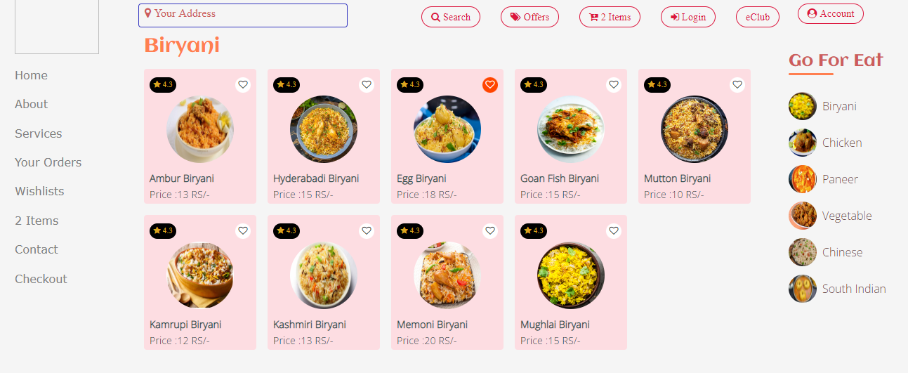

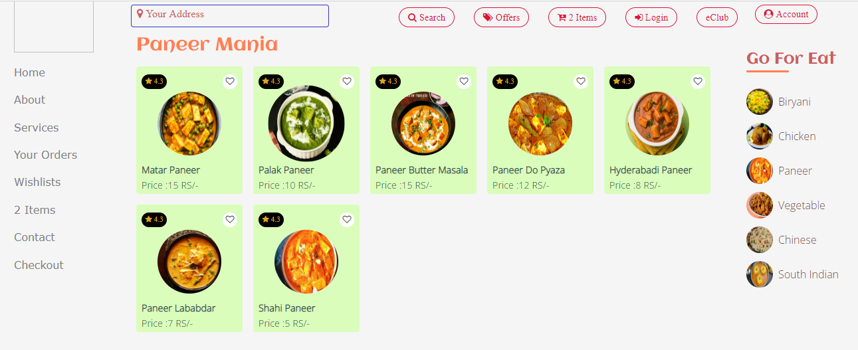

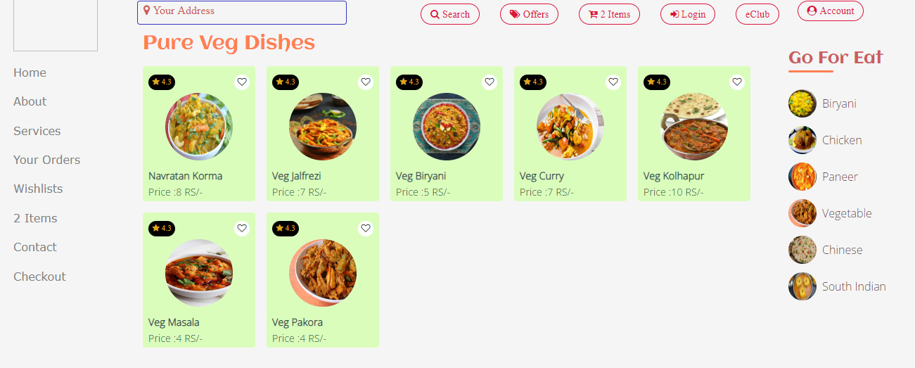

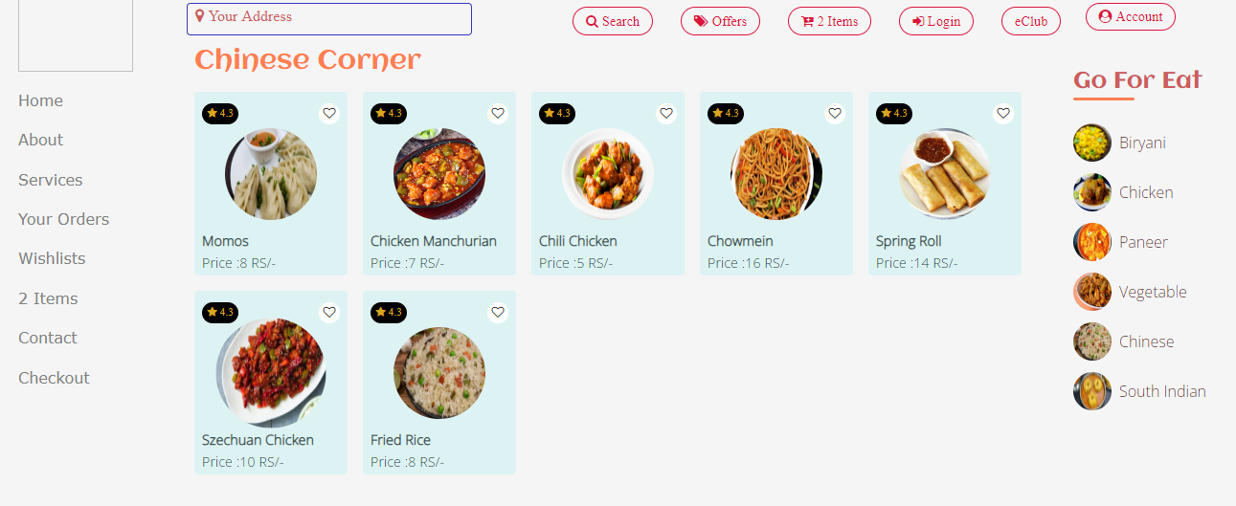

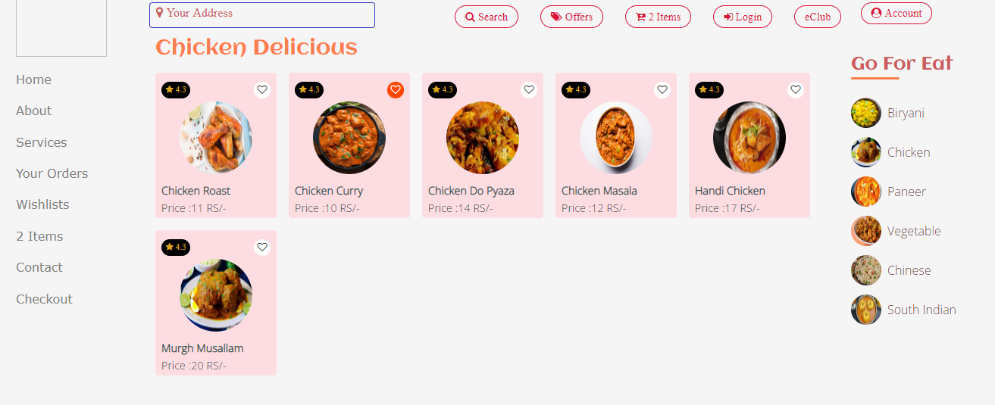

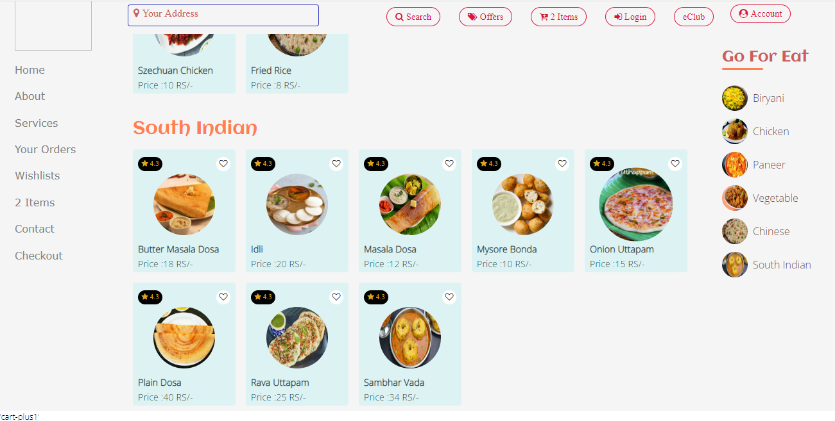

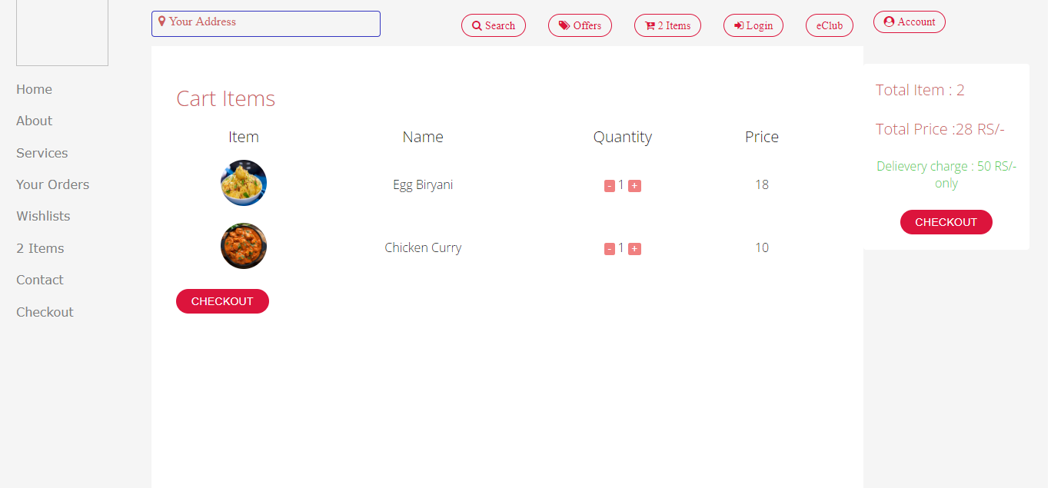

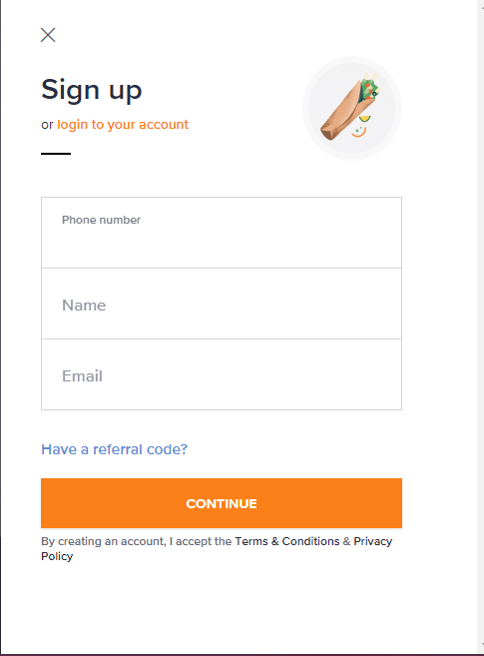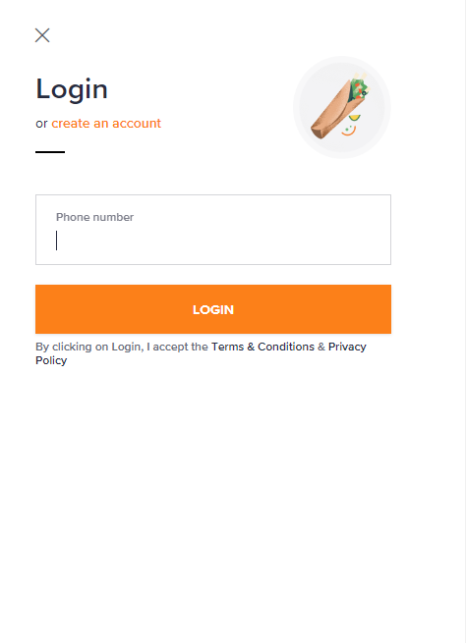

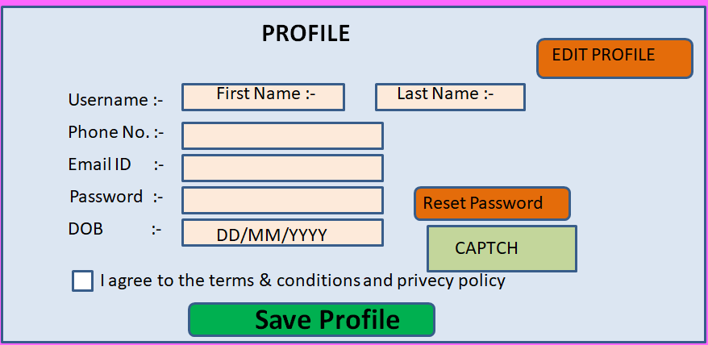

**Popular restaurants in and around Kolhapur**

